CMPE314 – SOFTWARE ENGINEERING
Lab 3 Solution: Use Case Diagrams
Project: FitTrack – Personal Fitness Companion
Group 3/1: Tawfig Malik (22115813), Lahsen Aittjiou (22118897), Hassan Eihab HassanAli (22211935)

Part 1 – Online Bookstore sample
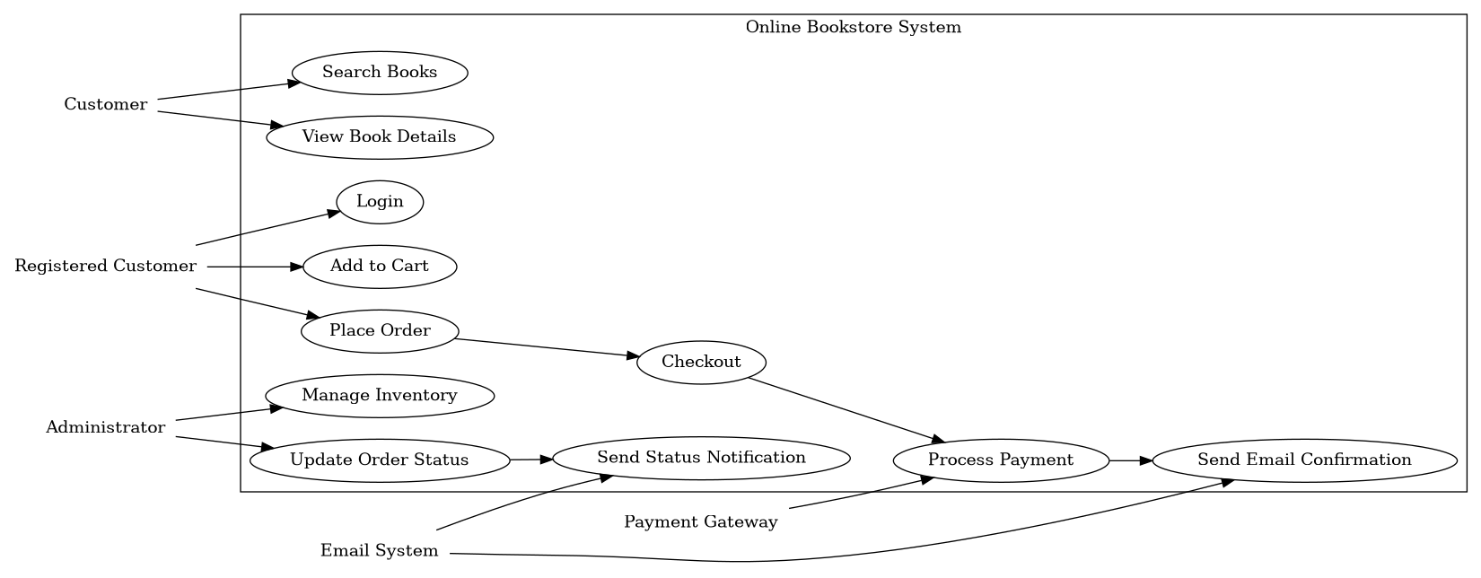
Actor | Main use cases
Customer | Search books, view details
Registered Customer | Login, add to cart, place order, checkout
Administrator | Manage inventory, update order status
Payment Gateway | Process payment
Email System | Send confirmations and notifications

Part 2 – FitTrack use case diagram
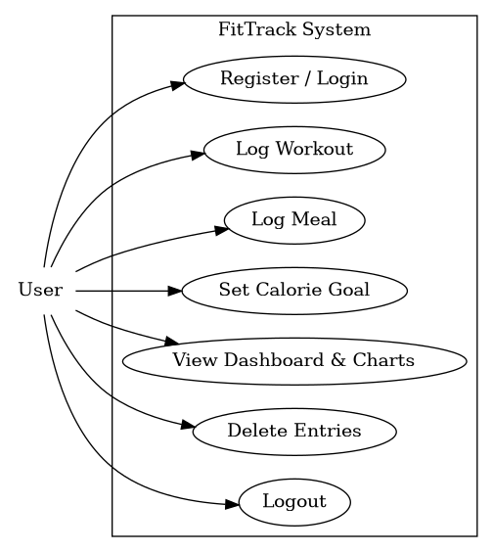
Use case | Description
Register / Login | User creates account or accesses dashboard.
Log Workout | User enters workout type, duration, calories, and date.
Log Meal | User enters meal name, calories, and date.
Set Calorie Goal | User sets a daily calorie target.
View Dashboard & Charts | System shows today snapshot and weekly chart.
Delete Entries | User removes incorrect workout or meal records.
Logout | User ends session and returns to login screen.

